No Injection in search tab

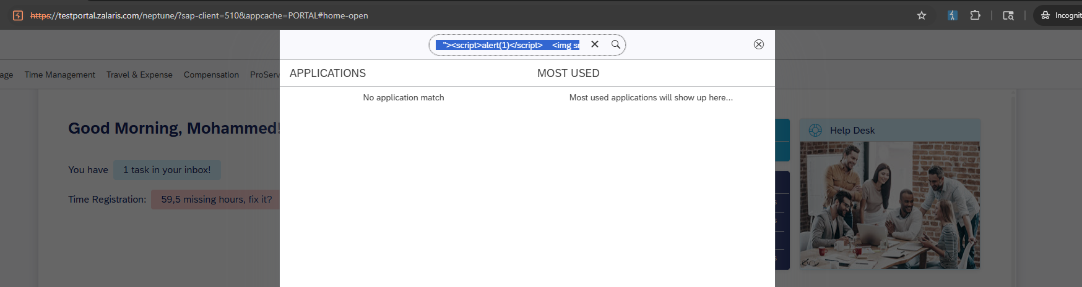

No injection in Inbox Tile serach tab

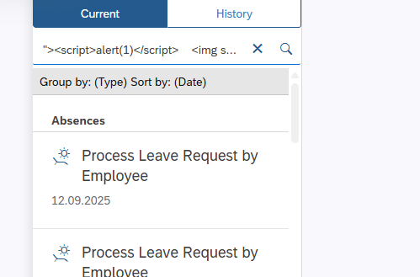

Injection issues in Time registration Record absence and record working hours tile

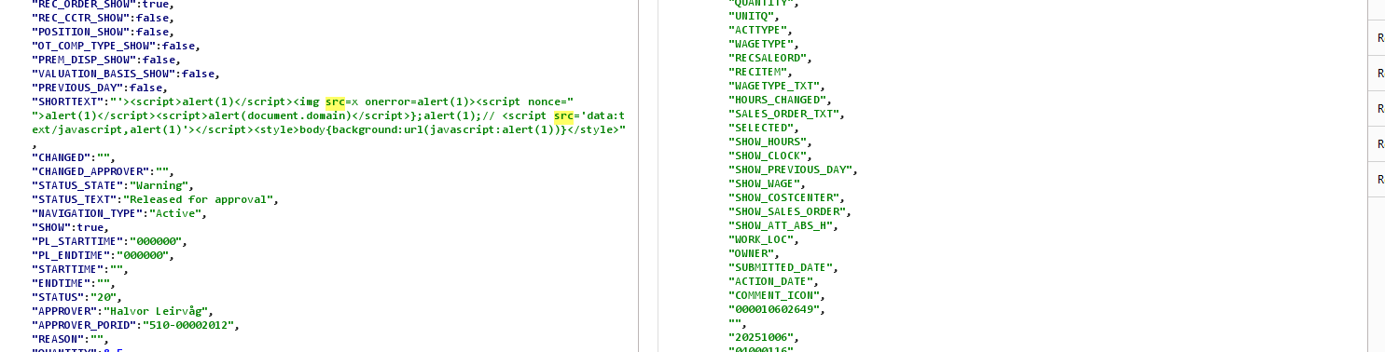

Injected in time registration save template , no XSS is received

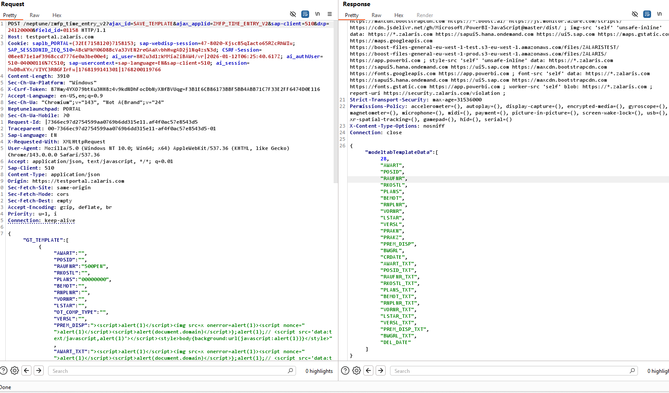

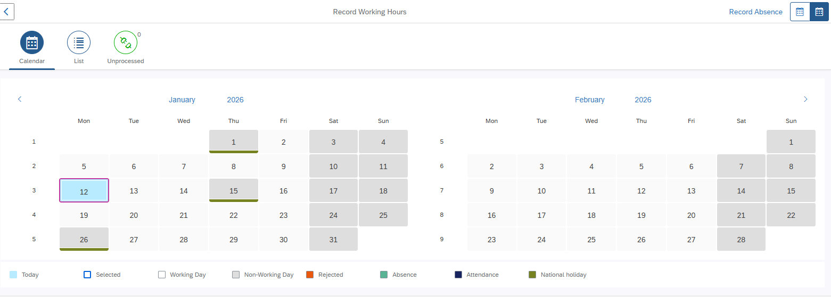

Travel and expense injected scripts are not executed

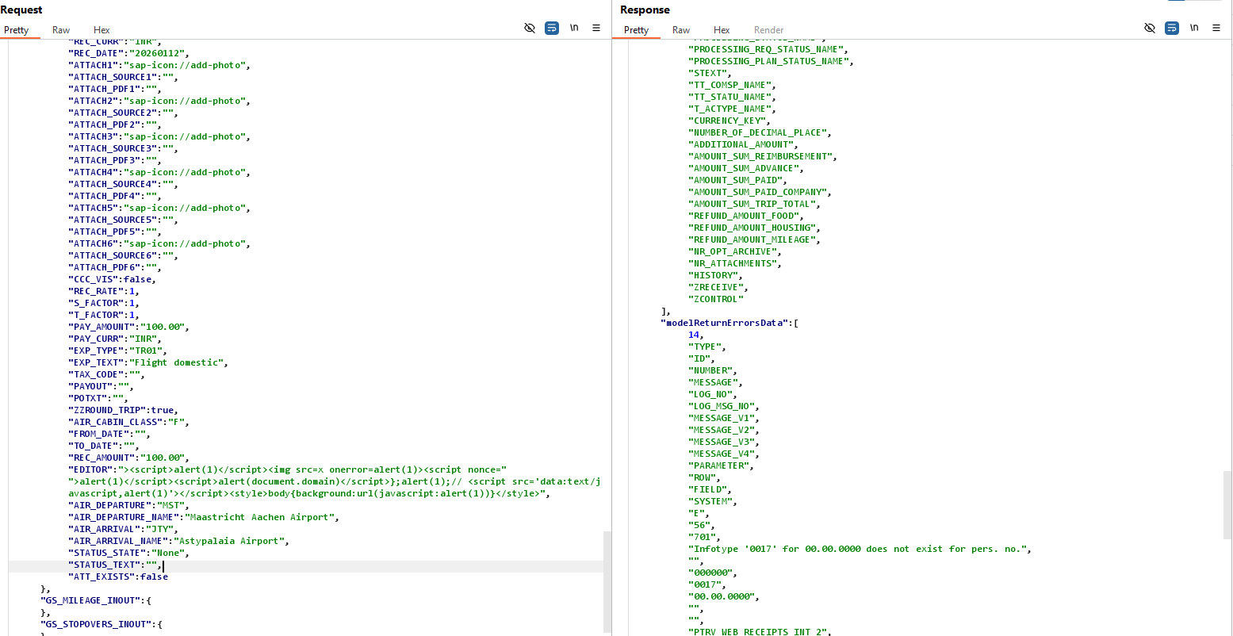

Received error and the script is not executed

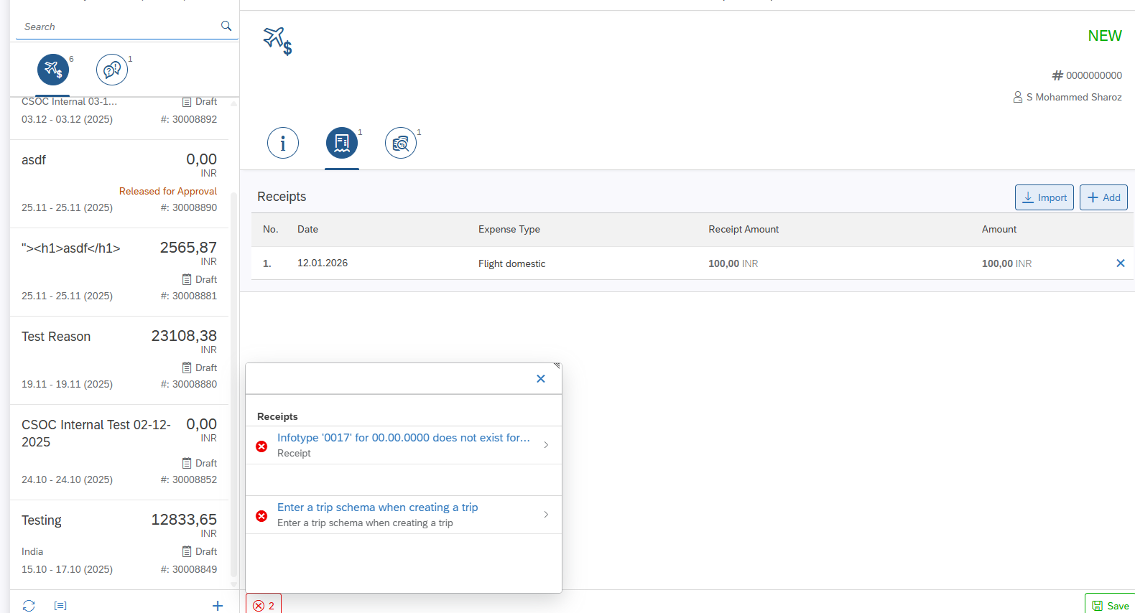

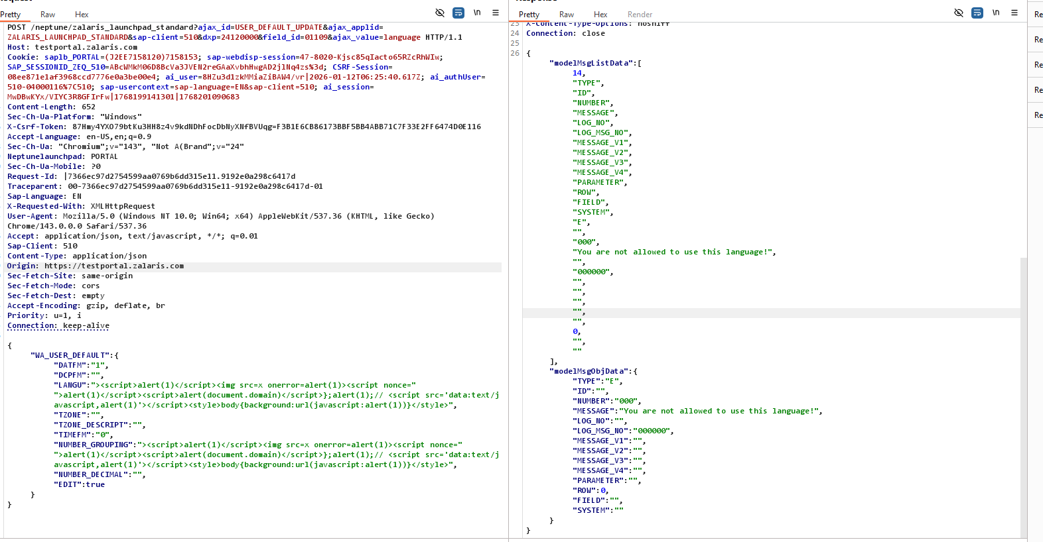

In User settings not allowed to upload XSS scripts

